Module 4 training details

Class training

Informatica Activity 1:

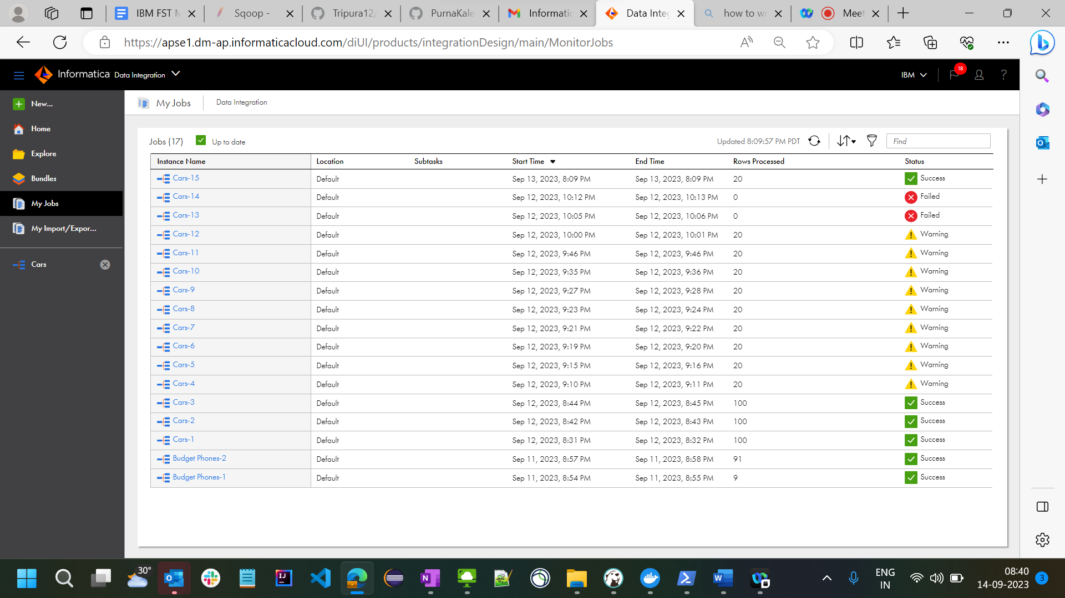

**Activity for Min car Prices**



